Creating Blackboard content

# What?

Currently, the Content Interface is designed to be embedded within the [Blackboard Learn system](https://en.wikipedia.org/wiki/Blackboard_Learn) (Blackboard). Blackboard provides an array of content, assessment (assignment submission points, quizzes), other tools (e.g. discussion forums etc.) and other functionality (e.g. [adaptive release](https://help.blackboard.com/Learn/Administrator/Hosting/Tools_Management/Adaptive_Release), [Review Status](https://help.blackboard.com/Learn/Administrator/Hosting/Tools_Management/Review_Status), [course links](https://help.blackboard.com/Learn/Instructor/Course_Content/Create_Content/Create_Course_Materials/Link_to_Content_and_Tools#what-is-a-course-link_OTP-0) etc.) that are an important part of a course site.

You will want to provide access to and use this Blackboard content, tools and functionality in your content. The following shows how, including:

* Two different ways of creating **indirect links** to Blackboard resources
  1. Indirect link to a menu item – *Blackboard Menu Link* style.
  2. Indirect link to a content item – *Blackboard Content Link* style.
* Using [Review Status](https://help.blackboard.com/Learn/Administrator/Hosting/Tools_Management/Review_Status).
* Using [Adaptive Release](https://help.blackboard.com/Learn/Administrator/Hosting/Tools_Management/Adaptive_Release).

## Direct links will create problems when copying course content

You can link directly to a page on Blackboard, just like any other page on the web. **But it’s a bad idea.**

A direct link looks like a normal web link e.g. <https://bblearn.griffith.edu.au/webapps/blackboard/content/listContent.jsp?course_id=_82534_1&content_id=_5578514_1>

### Course copies break direct links

Most Blackboard sites are trimester or study period specific. The next offering of the course will have a different Blackboard site. With different URLs. This means that any direct links from previous offerings will not point to the new course site. They’ll still point to the old site.

### Indirect links work with course copies

The methods shown below work safely across course copies.

# Indirect link to a menu item – Blackboard Menu Link

Every Blackboard course will have a course menu. For example, Figure 1 shows one course menu. Each course menu consists of menu items. Figure 1 includes menu items like: Welcome; Workshop Resources; and, Collaborate Ultra.

The *Blackboard Menu Link* style provides a way to link indirectly to items in the Course Menu.

**Avoid using the browser-based version of Word for this task**

Microsoft provides both a Desktop and browser-based version of Word. Typically both work the same, but [there are differences](https://support.microsoft.com/en-us/office/differences-between-using-a-document-in-the-browser-and-in-word-3e863ce3-e82c-4211-8f97-5b33c36c55f8).

One point of difference is how they operate when inserting the type of links required for this task. i.e. the browser-based version of Word typically fails at the task.

Figure 1 - Example Blackboard course menu

To use the *Blackboard Menu Link* style you:

1. Write the text to which you will add the link.
2. Identify the name of the menu item to like to.
3. Create a link with that name as the destination.
4. Apply the *Blackboard Menu Link* style to the link.

The following sections illustrate

## 1. Write the text

For example, the following quote

Participate in online tutorials by using Collaborate Ultra.

Where I’d like *using Collaborate Ultra* to be a link.

## 2. Identify the name of the menu item

I’d like *using Collaborate Ultra* to link to the same place as the *Collaborate Ultra* menu link shown in Figure 1.

Hence the name I’m interested in – **Collaborate Ultra**

## 3. Create the link

Use [Microsoft Word’s ability](https://support.office.com/en-us/article/create-or-edit-a-hyperlink-5d8c0804-f998-4143-86b1-1199735e07bf) to create a link using the outputs of the previous two steps. As shown in Figure 2.

Participate in online tutorials by [using Collaborate Ultra](Collaborate%20Ultra).

**Make sure the name and the link match**

The Content Interface tries to make an exact match. If the link you’ve used doesn’t match exactly one of the menu item names. A link will not be created.

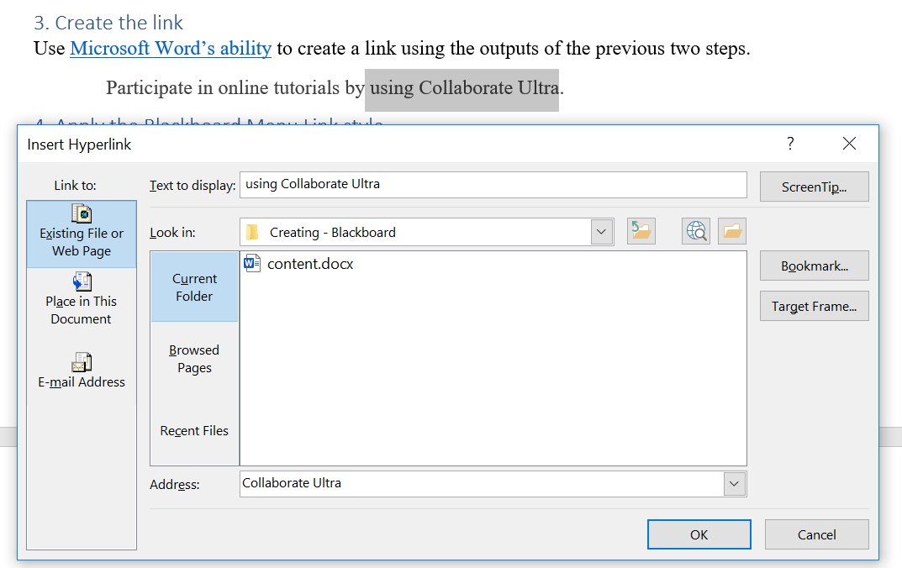

Figure 2 - Creating the link

## 4. Apply the Blackboard Menu Link style

The link created in the previous step is a normal link. i.e. it will search for a web page with the URL **Collaborate Ultra**. It will fail. We need to tell the Content Interface that this is not a normal link. It is in fact a **Blackboard Menu Link**.

We do this by applying the *Blackboard Menu Link* style to the link. i.e. select all of the link and then choose the *Blackboard Menu Link* from the styles menu.

If your Word document is using an appropriate template then the colour of the link should change in line with what you see in Figure 3. The normal link (Microsoft Word’s ability) is blue and underlined. The *Blackbard Menu Link* (using Collaborate Ultra) is red and underlined.

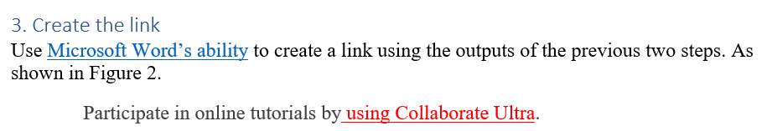

Figure 3 - Result of applying the Blackboard Menu Link style

# Indirect link to content item – Blackboard Content Link

[Blackboard Content Areas](https://utlv.screenstepslive.com/s/faculty/m/BlackboardLearn/l/185501-creating-a-content-area) are commonly used to organise lists of content items. The Content Interface is typically implemented as two or three content items in a content area. [Other content items and tools](https://blackboardhelp.usc.edu/administering-your-course/customizing-your-course/adding-content-areas-to-the-course-menu/) can be added to a Content Area. Many of those content items and tools are links elsewhere in Blackboard.

**Avoid using the browser-based version of Word for this task**

Microsoft provides both a Desktop and browser-based version of Word. Typically both work the same, but [there are differences](https://support.microsoft.com/en-us/office/differences-between-using-a-document-in-the-browser-and-in-word-3e863ce3-e82c-4211-8f97-5b33c36c55f8).

One point of difference is how they operate when inserting the type of links required for this task. i.e. the browser-based version of Word typically fails at the task.

For example, Figure 4 shows an example content area showing four content items with titles, including

1. **Content Interface** – the item that contains content produced by the Content Interface.
2. **Chat about the content interface** – a discussion board.
3. **Take a quiz** – a quiz.
4. **Testing** – another content area.

The titles for each of the last three content items shown are underlined. Indicating that these titles are also links. If you click on these links, you are taken to the relevant discussion board, quiz, or content area.

This section illustrates how you can use these items to create links within the Content Interface. Allowing you to create indirect links to elsewhere in Blackboard.

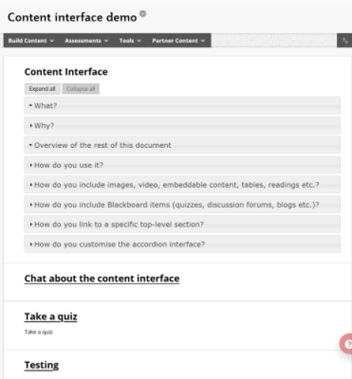

Figure 4 - Example Content Area

## For example

The following assume that the aim is to link to a discussion board. For example, the following where if you click on the link you will be taken to a discussion board to share your response.

Share your responses in the discussion board.

The four steps of this process is essentially the same as the four steps of the previous section. The only difference here is that rather than using a menu item to find the link, we’ll be using a content item.

## 1. Write the text

The first step is to write in the Word document the text where the link will originate. E.g.

Share your responses in the discussion board.

## 2. (Create and) Identify the name of the content item

To use this approach there has to be a content item on the current page in Blackboard that provides the link we wish to use. In this case, we’d like a link to the discussion board. Meaning a discussion board item needs to be added [to the content area](https://www.stthom.edu/Public/getFile.asp?File_Content_ID=110647).

For example, Figure 5 shows that a discussion board linked named *Discussion Board* has been added to this page.

You need to know the exact name of the content item to create the link.

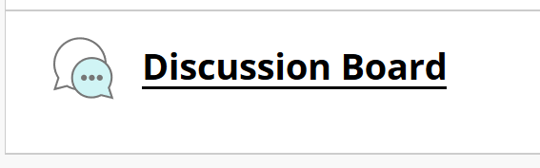

Figure 5 - Example discussion board added to a content area

## 3. Create the link

Use [Microsoft Word’s ability](https://support.office.com/en-us/article/create-or-edit-a-hyperlink-5d8c0804-f998-4143-86b1-1199735e07bf) to create a link using the outputs of the previous two steps. As shown in Figure 6.

Share your responses in [the discussion board](Discussion%20Board).

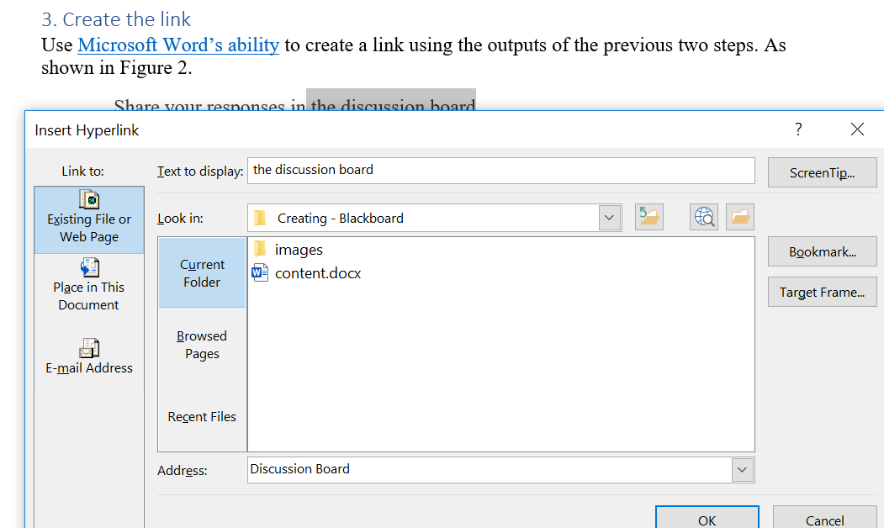

Figure 6 - Adding link to content item

**Beware Word special characters – copy and paste**

Matching the link address and the item name is an exact match. *Maximise* is different to *maximise*.

Microsoft Word automatically replaces some text characters with others. For example, [smart quotes](https://support.microsoft.com/en-us/office/smart-quotes-in-word-702fc92e-b723-4e3d-b2cc-71dedaf2f343) and [hyphens and dashes](https://support.microsoft.com/en-au/help/284897/autoformat-converts-some-hyphens-to-long-dashes-in-word). This can create some less than apparent differences.

When adding the content type to the Blackboard page, rather than type the name, copy and paste it from Word.

**Beware creating links in the online version of Word**

Experience suggests that the online version of Word doesn’t create links the same way as the desktop Word application.

## 4. Apply the Blackboard Content Link style

The link created in the previous link is a normal web link. As such, it will not work as it stands. To make it work as an indirect link the *Blackboard Content Link* style needs to be applied to the link (e.g. Figure 7)

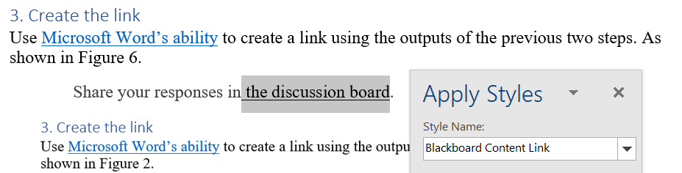

Figure 7 - Applying the Blackboard Content Link style

If the *Blackboard Content Link* style is applied correctly in a document that is based on a template, then the colour of the link will be black. For example, Figure 8 shows the difference between a normal link (blue underlined) and a *Blackboard Content Link* (black underlined)

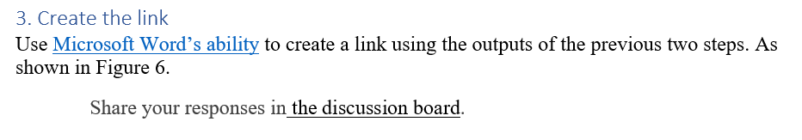

Figure 8 - Different appearance of Blackboard Content Links

# Integrating the Blackboard “Review Status” feature

The [Blackboard Review Status feature](https://utlv.screenstepslive.com/s/faculty/m/BlackboardLearn/l/509478-setting-up-review-status) provides a way for students to mark items as reviewed and for teaching staff to track how students have marked items as reviewed.

Integrating the Content Interface with the *Review Status* feature allows students to mark specific accordions (sections) as reviewed.

## For example

This section (Integrating the Blackboard “Review Status”) has been set up to enable “Review Status”. When viewed in Blackboard it will appear as shown in Figure 9 and Figure 10. These two figures show the two status of Review Status

1. Mark Reviewed; and  
   i.e. the student has yet to mark this section has reviewed
2. Reviewed.

i.e. the student has marked this section as reviewed

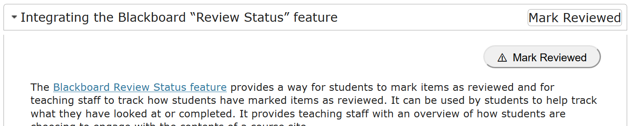

Figure 9 - Review status turned on - Waiting for student to Mark Reviewed

The two figures illustrate the two components added when Review Status is enabled:

1. Status label; and  
   The heading of the section has a label added to indicate the status of the section – reviewed or not
2. Action button.  
   The first content within the section is now an action button that allows the student to toggle whether the section is reviewed or not. Clicking on the *Mark Reviewed* button (Figure 9) results in the section to be updated to be *Reviewed* (Figure 10). Clicking on the *Reviewed* button (Figure 10) will result in the section being updated to unreviewed (Figure 9)

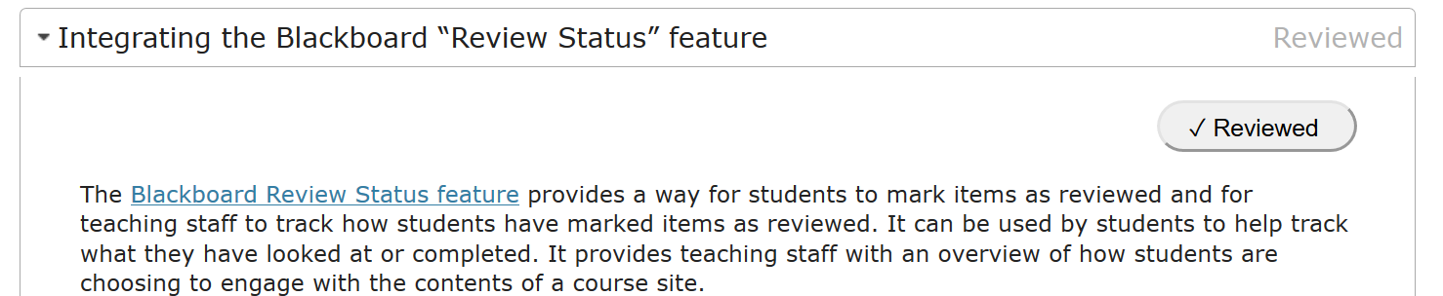

Figure 10 - Review status enabled - Student has marked as reviewed

### Steps to turn on “Review Status”

The following sections outline the 5 or 6 steps to enable “Review Status”

## 1. Identify which Word document heading(s) you will apply “Review Status”

The Content Interface allows you to turn on “Review Status” for specific (accordion) sections of your Word document. The start of (accordion) sections is indicated by their heading (*Heading 1* or *Heading 2* style) and a section includes all content up until the next heading of the same level.

To turn “Review Status” on for a section, you first have to identify the full text of the relevant heading. In this example, I wanted to enable “Review Status” for this section. The full text of the heading for this section (a *Heading 1* style). The text of that heading is

Integrating the Blackboard “Review Status” feature

I’ve copied that text into the clipboard.

**Beware special character – use copy and paste**

Typically, Microsoft Word will automatically convert certain characters. For example, quotes will be come [smart quotes](https://support.microsoft.com/en-us/office/smart-quotes-in-word-702fc92e-b723-4e3d-b2cc-71dedaf2f343) and [(some) hyphens will become em/en dashes](https://support.microsoft.com/en-au/help/284897/autoformat-converts-some-hyphens-to-long-dashes-in-word).

Blackboard does not do this conversion.

You may not notice the difference, but software does. While you may think you’ve typed in the name of the heading, you may have missed some of these auto conversions.

To avoid this problem, copy the text of a heading.

## 2. Change the heading style

Normally, headings that define accordion sections will have either the *Heading 1* or *Heading 2* styles applied. To use the Blackboard “Review Status” the styles need to be changed to either the *Blackboard Item Heading* or *Blackboard Item Heading 2* styles. This [“apply styles” page](https://support.microsoft.com/en-us/office/apply-styles-f8b96097-4d25-4fac-8200-6139c8093109) shows how to apply a new style.

To help distinguish between these two sets of heading styles, the default Content Interface template makes them look different.

*Heading 1* and *Heading 2* styles will use a larger, blue font (Figure 11)

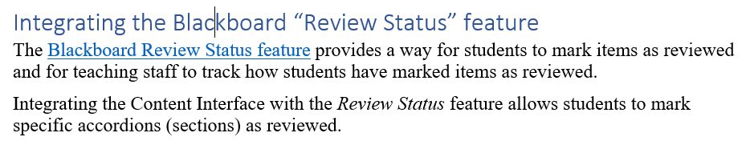

Figure 11 - Heading 1 style

In contrast, the *Blackboard Item Heading* and *Blackboard Item Heading 2* styles will use a white font on a black background (Figure 12).

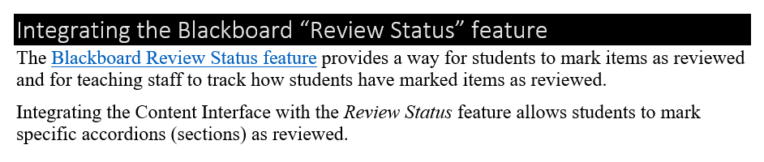

Figure 12 - Blackboard Item Heading style

**Blackboard Item Heading sections will be initially hidden from students**

The *Blackboard Item Heading* styles are intended to be paired with a matching Blackboard content item (the next step is creating one). If there is no matching Blackboard content item for a *Blackboard Item Heading* element, then the whole section will be hidden from students (but visible to teaching staff).

For more information, see the *Change the styles* section in the *Using the adaptive release function* section below.

## 3. Add a Content Item to the page with the same name

“Review Status” is a Blackboard feature. It has to be applied to an item within a Blackboard course site. Hence to enable “Review Status” for your section, you need to [add a content item](https://utlv.screenstepslive.com/s/faculty/m/BlackboardLearn/l/185559-creating-a-content-item) in Blackboard with the same name on the same page as the Content Interface.

Figure 13 shows the process of adding a content item to the Blackboard page on which this document has been placed. The name matches the text of the heading of the section. The body of the content item can be left empty

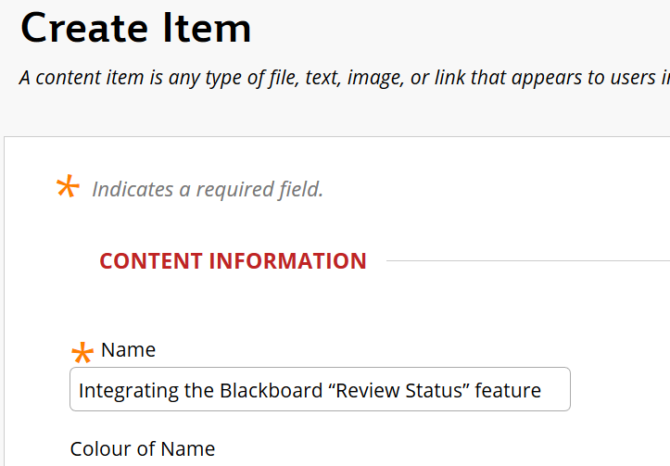

Figure 13 - Adding a content item matching the section

With *Edit Mode* on this newly added item will appear on the page (e.g. see Figure 14). However, when *Edit Mode* is off (i.e. when viewed by students) this item will be hidden. Its only purpose is to track whether “Review Status” has been enabled.

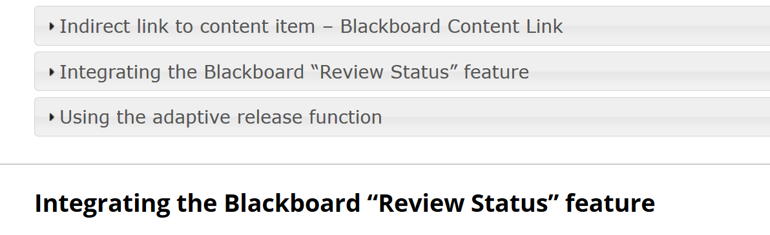

Figure 14 - Blackboard content item added with name matching section title

## 4. Turn the review status for the content item

Initially, a new content item does not have “Review Status” turned on. Hence the next step is to [turn “Review Status” on](https://utlv.screenstepslive.com/s/faculty/m/BlackboardLearn/l/229916-enabling-review-status).

Once you have done this, the content item will be modified to indicate that it has been enabled (see Figure 15).

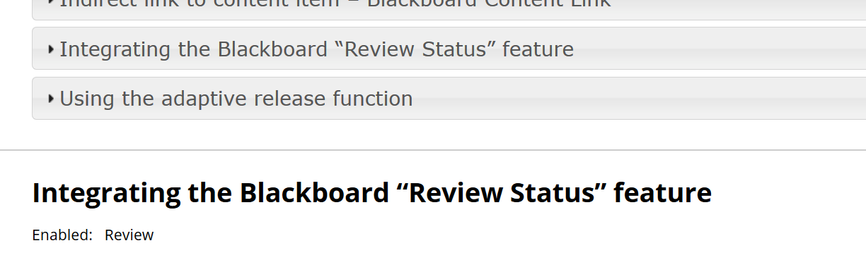

Figure 15 - Content item showing Review Status enabled

If you look closely at Figure 15 you will see that while “Review Status” has been enabled, the matching accordion in the Content Interface (above it) does NOT have the “Mark Reviewed” status label showing.

**Review Status only appears with Edit Mode off**

In Figure 15, Edit Mode is on. This is why we can see the newly added content item at the bottom. It’s also why we can’t see the “Mark Reviewed” status label.

## 5. Check that it works – Turn Edit Mode off

To check that “Review Status” has been enabled, you need to turn Edit Mode off. With Edit Mode off, if everything is working, then the “Mark Reviewed” status label will show on the appropriate accordion heading and the content item will not show (Figure 16). Open up the accordion and should see the “Mark Reviewed” button (Figure 9).

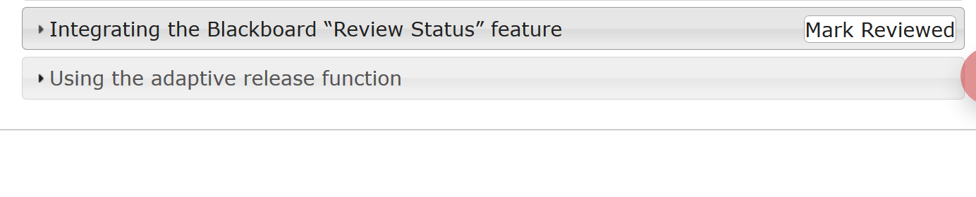

Figure 16 - Checking "Review Status" is working with the Content Interface - turn Edit Mode off

## 6. (Optional) Change the text on the “Review Status” label and button

As shown above, when you turn on “Review Status” a “Review Status” label and button will be added. By default, the label and button will use the text

* Mark Reviewed; and,  
  To indicate that the student has not yet reviewed the section.
* Reviewed.  
  To indicate that the section has been reviewed.

One or both of these default texts can be changed. You do this by adding parameters to the name of the Content Interface item. This is the Blackboard item into which the converted Word document content is pasted.

For example, Figure 17 shows a page (with Edit mode on) where labels have been changed to *Completed* and *Not Completed*.

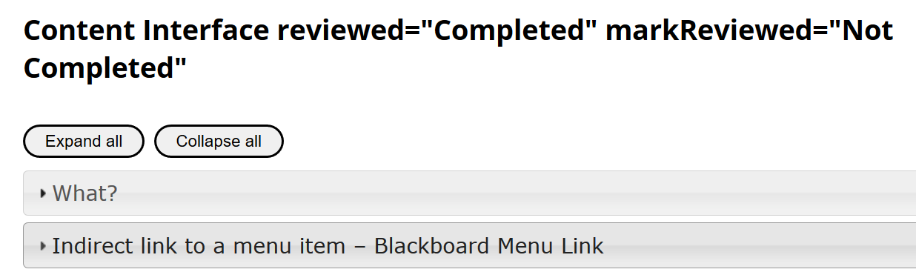

Figure 17 - Changing text for "Review Status" label and buttons

With Edit Mode off, the “Review Status” label and buttons will show *Not Completed* (Figure 18)

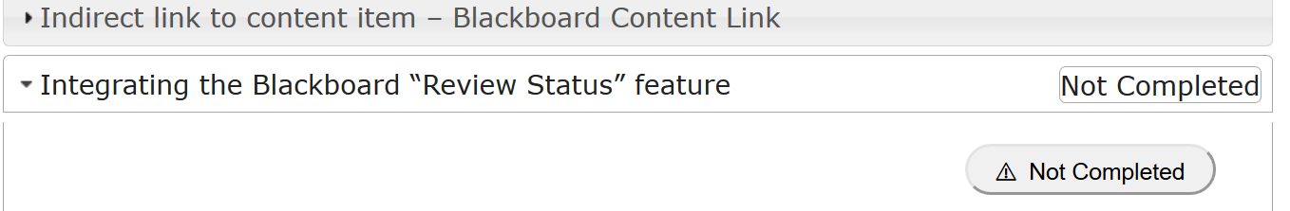

Figure 18 - "Review Status" showing change to "Not Completed"

And *Completed* (Figure 19)

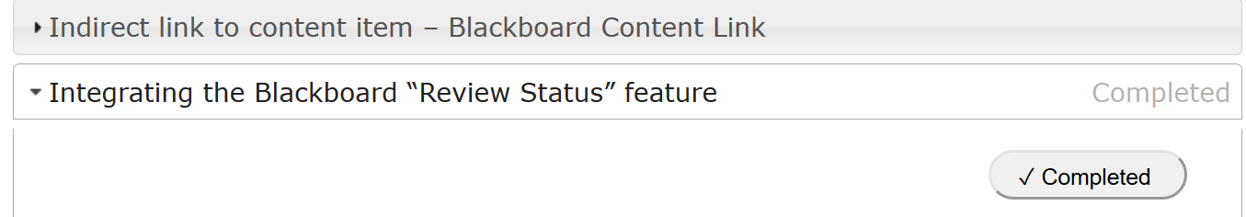

Figure 19 - "Review Status" showing change to "Completed"

# Hide sections using Blackboard’s availability control mechanisms

Blackboard provides two different ways by which you can control which students see which content, including:

1. [Controlling availability](https://help.blackboard.com/Learn/Instructor/Original/Course_Content/Create_Content/Edit_and_Manage_Content#control-availability-of-content_OTP-3) – make content unavailable or apply date and time restrictions.
2. [Adaptive release](https://help.blackboard.com/Learn/Instructor/Original/Course_Content/Release_Content) – limit availability based on numerous different characteristics (e.g. group membership, individual usernames etc).

Both these methods can be used to hide sections in a Content Interface document.

Do NOT rely on this method to hide important information.

This method hides the information from the student after the information has reached the student’s web browser. Meaning that with sufficient knowledge (or luck) a student could potentially view the information.

To securely hide information use the Blackboard features directly.

## What?

For example, Figure 20 shows a small section of a Content Interface document. One of the sections is titled *For example, hide this* section. For some reason, I don’t want students to see this section (yet).

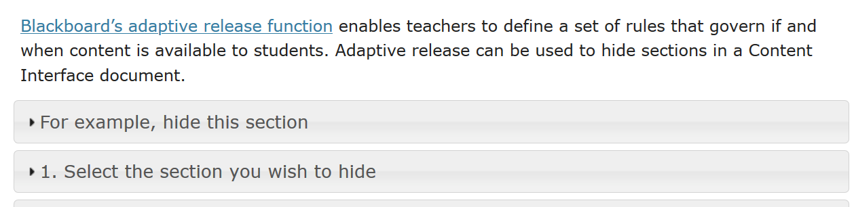

Figure 20 - Blackboard Item Heading section with adaptive release applied (Edit Mode on)

If I follow the instructions below, then when students view this page they will see Figure 21. i.e. they are unable to see the *For example, hide this section* section.

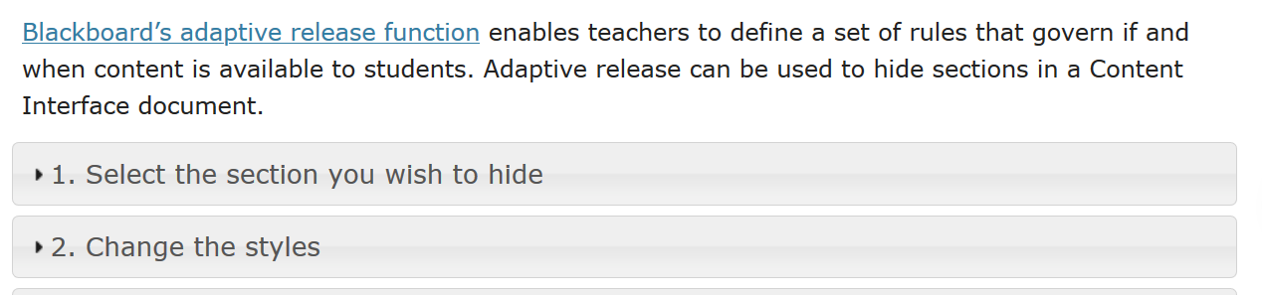

Figure 21 - Blackboard Item Heading section with adaptive release applied (Edit Mode off)

## How?

This method is based on the *Review Status* approach described above.

### 1. In Word, select the section you wish to hide

Like “Review Status” (above) adaptive release is applied to sections of your Word document. These sections are defined by headings. Adaptive release can only work on the top two levels of headings (heading 1 and heading 2).

In this example, the section I wanted to hide was the section called *For example, hide this*

For example, hide this

Some information that I wish to hide

### 2. In Word, change the styles of the heading

Normal *Heading 1* and *Heading 2* styles will not work. If you want to hide a section, you need to change its style from:

* *Heading 1* to *Blackboard Item Heading*; or,
* *Heading 2* to *Blackboard Item Heading 2*.

If you’re using a Content Interface template Word document then the *Blackboard Item Heading* styles will appear as a heading with a black background and white text (Figure 22).

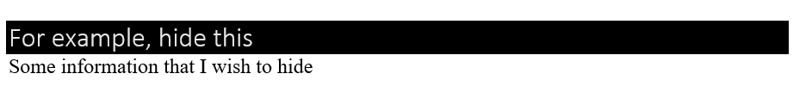

Figure 22 – A Word document heading using the *Blackboard Item Heading* style

### 3. In Blackboard, add *hideMissingSections* to the Content Interface item’s name

To make a section of the document disappear the Content Interface item’s name must include *hideMissingSections*. As the name suggests, this tells the Content Interface to hide any sections with *Blackboard Item Heading* styles that don’t have a matching Blackboard content item. Figure 23 shows *hideMissingSections* being added to a Content Interface item’s name. Figure 24 shows that same item being viewed with *Edit Mode* on (students never see the Content Interface name).

Without *hideMissingSections* nothing will be hidden from students

|  |  |
| --- | --- |
| Figure - Adding hideMissingSections to the Content Interface item's name | Figure - Content Interface item with hideMissingSections added (edit mode on) |

### 4. Create the matching Blackboard content item

To control who can see what section you will use Blackboard’s availability or adaptive release functionality. This functionality must be applied to [a Blackboard content item](https://utlv.screenstepslive.com/s/faculty/m/BlackboardLearn/l/185559-creating-a-content-item). To connect this Blackboard Item to a section in the Content Interface, they must share **exactly** the same name.

Create a new content item on the Blackboard page with the same name as the section with the *Blackboard Item Heading* style.

Copy and pasting the heading from Word is perhaps the best way to ensure similarity.

Word’s auto-correct tends to transform normal characters e.g. [smart quotes](https://support.microsoft.com/en-us/office/smart-quotes-in-word-702fc92e-b723-4e3d-b2cc-71dedaf2f343), em dash etc.

## 5. Configure the new Blackboard content item’s availability

Use Blackboards [availability](https://help.blackboard.com/Learn/Instructor/Original/Course_Content/Create_Content/Edit_and_Manage_Content#control-availability-of-content_OTP-3) or [adaptive release functionality](https://help.blackboard.com/Learn/Instructor/Original/Course_Content/Release_Content) to change who and when is able to access the item.

With Edit Mode on, Blackboard will indicate the changes you’ve made. For example, Figure 25 shows the *For example, hide this section* Blackboard content item, including a message from Blackboard about availability.

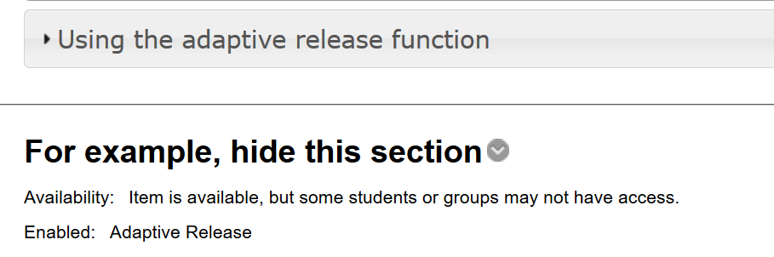

Figure 25 - Blackboard content item with adaptive release applied

## 6. In Blackboard, check if it works

It can be difficult to check if the section will be hidden correctly, mainly because the availability conditions you’ve configured may not apply to you. For example, you may not be able to test whether members of a particular group can see a section because you are not a member of that group. Similarly, you may not have submitted an assignment, achieved a particular grade etc.

However, what you see in Blackboard can provide some clues depending on how you are viewing the page. The following describe what you might see.

### *Edit Mode* on

With *Edit Mode* on you should see all sections regardless of what availability conditions apply. Sections that have availability conditions will have a message added to the section title

(section hidden from some/all students)

Figure 26 shows an example. The *Tutorials* section has some availability conditions applied and is showing the message. The remaining sections do not have availability conditions.

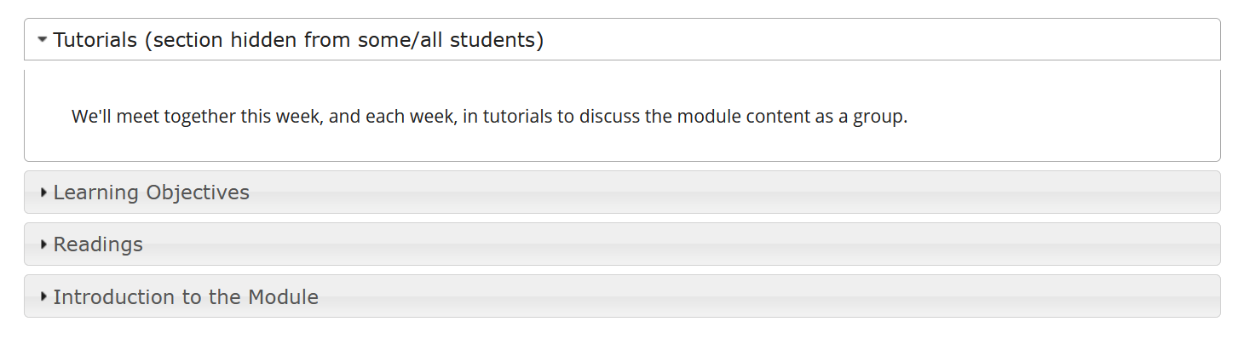

Figure 26 - Example section with availability conditions - Edit Mode on

### *Edit Mode* off

With *Edit Mode* off sections with availability conditions that apply to you will disappear. If the conditions don’t apply to you, the section will still be visible.

Figure 27 shows the same page as Figure 26, however, this time *Edit Mode* is off and the availability conditions apply. Hence the *Tutorials* section has disappeared.

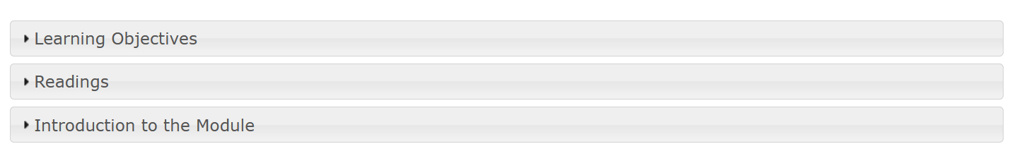

Figure 27 - Same page as Figure 26 with Edit Mode off - showing section being hidden